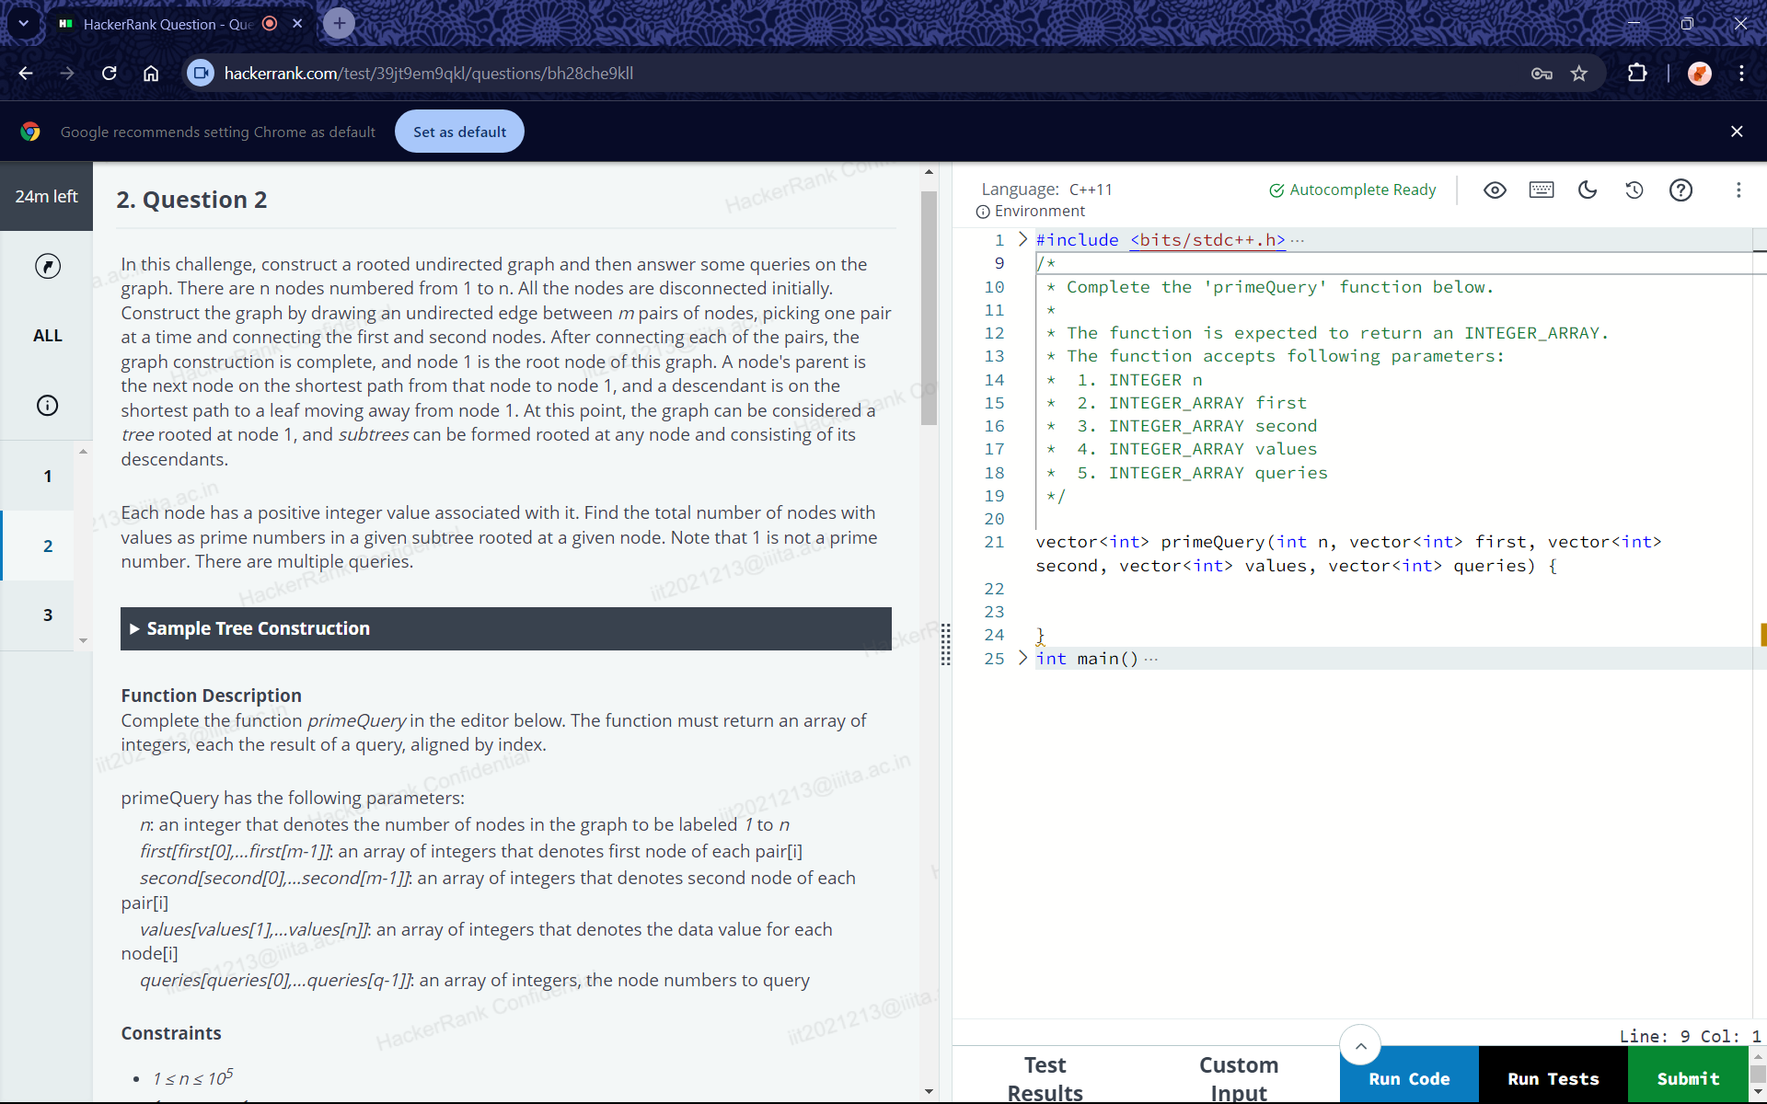
<
T
H HackerRank Question - Que O X
C
A
hackerrank.com/test/39jt9em9qkl/questions/bh28che9k|l
Google recommends setting Chrome as default
24m left
2. Question 2
Set as default
2
1
ALL
213
a.ac
HackerRank Com
Language: C++11
Environment
In this challenge, construct a rooted undirected graph and then answer some queries on the graph. There are n nodes numbered from 1 to n. All the nodes are disconnected initially. Construct the graph by drawing an undirected edge between m pairs of nodes, picking one pair at a time and connecting the first and second nodes. After connecting each of the pairs, the graph construction is complete, and node 1 is the root node of this graph. A node's parent is the next node on the shortest path from that node to node 1, and a descendant is on the
shortest path to a leaf moving away from node 1. At this point, the graph can be considered ank Co
tree rooted at node 1, and subtrees can be formed rooted at any node and consisting of its descendants.
ac.in
Each node has a positive integer value associated with it. Find the total number of nodes with values as prime numbers in a given subtree rooted at a given node. Note that 1 is not a prime number. There are multiple queries.
HackerRe
3
► Sample Tree Construction
iit2021213@iiita.
ckerp
Function Description
it202
Complete the function primeQuery in the editor below. The function must return an array of integers, each the result of a query, aligned by index.
Confidende
primeQuery has the following parameters:
2021213@iiita.ac.in
n: an integer that denotes the number of nodes in the graph to be labeled 1 to n first[first[0],...first[m-1]]: an array of integers that denotes first node of each pair[i] second[second[0],...second[m-1]]: an array of integers that denotes second node of each
pair[i]
values[values[1],...values[n]]: an array of integers that denotes the data value for each
node[i]213@iiita.a
queries[queries[0],...queries[q-1]]: an array of integers, the node numbers to query
Constraints
HackerRank Confice
•
1 ≤ n ≤ 105
::::::::
✔ Autocomplete Ready
✩
9
10
11
*
12 13
1 > #include <bits/stdc++.h> ...
*
* Complete the 'primeQuery' function below.
The function is expected to return an INTEGER_ARRAY.
*The function accepts following parameters:
14
*
1. INTEGER n
15
*
2. INTEGER_ARRAY first
16
*
3. INTEGER_ARRAY second
17
* 4. INTEGER_ARRAY values
18
* 5. INTEGER_ARRAY queries
19
*/
20
21
vector<int> primeQuery (int n, vector<int> first, vector<int> second, vector<int> values, vector<int> queries) {
2322
24
}
25 > int main() ....
iit2021213@iiita.
Test Results
Custom Input
Line: 9 Col: 1
Run Code
Run Tests
Submit
?
X
...
...

